Customer Portal
Index
1.Log in
2.New Institute registration
3.New Card user Registration
4. Dash Board
5.Dose report Download
6.Account statement,Invoices,Receipts,Credit note Debit Note.
7.online Payment
8.Notification/mails

1.Log In
Click Here
- Log on to www.ultratechlab.com
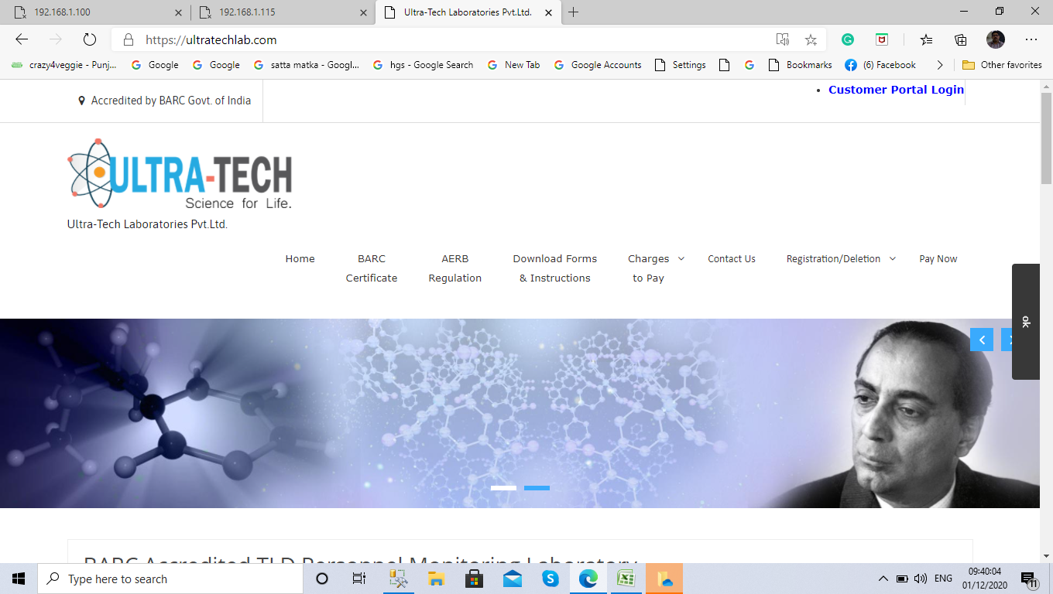
- Enter user id Password (default user name: 6 digit Institutecode,Password:1234)& Captcha
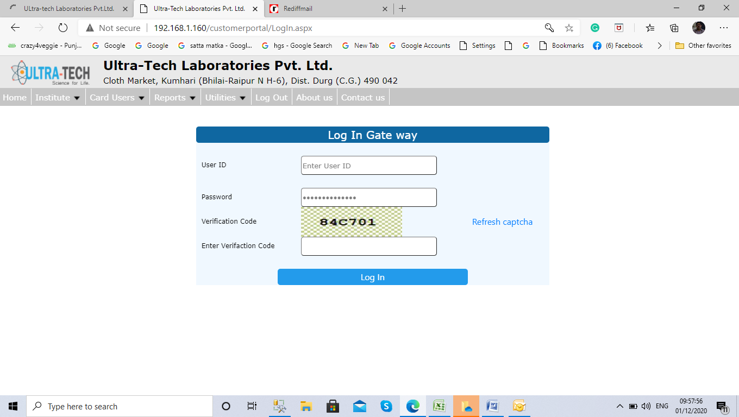

2.New Institute Registration
Visit website www.ultratechlab.com and click on new Registraion request
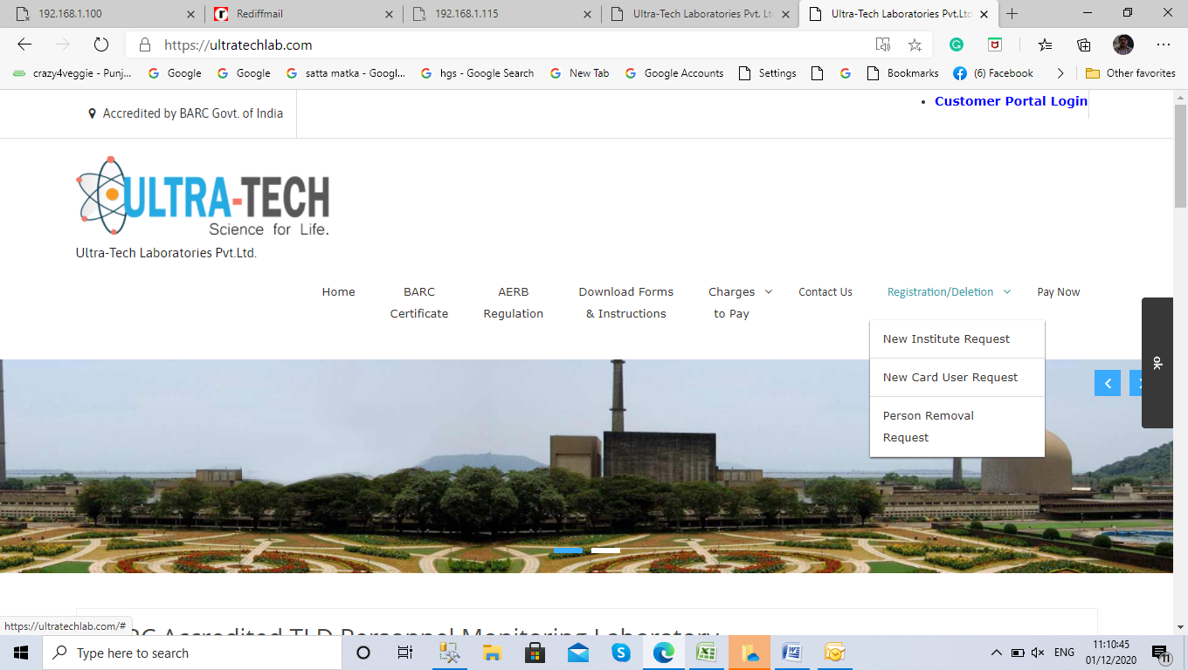
Person deletion request
New registration request

Enter Details and submit. You will get temporary id and Password for customer portal. Through Email.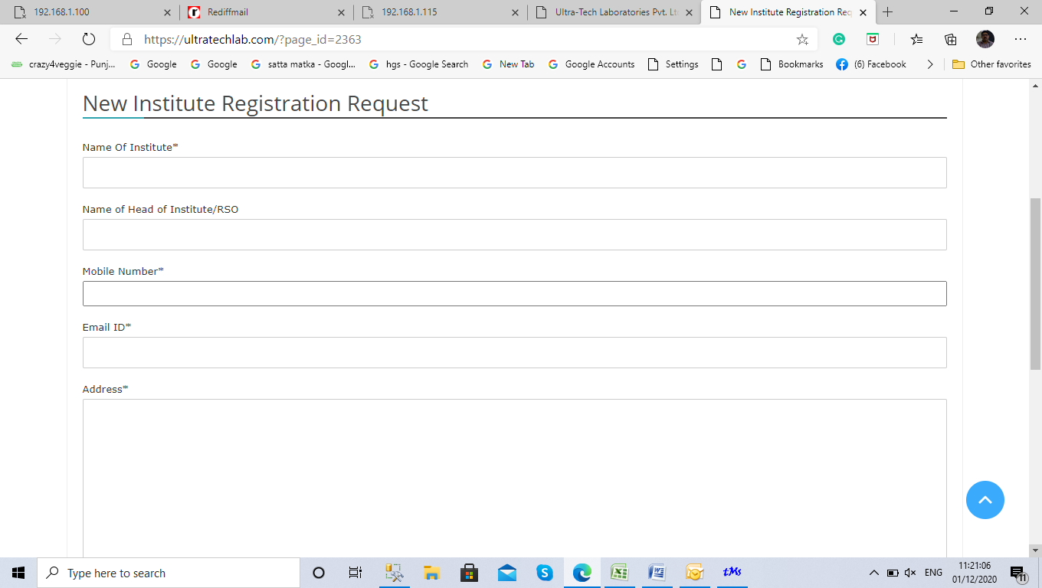
- Enter user id Password (default user name: 6 digit Institutecode,Password:1234)& Captcha

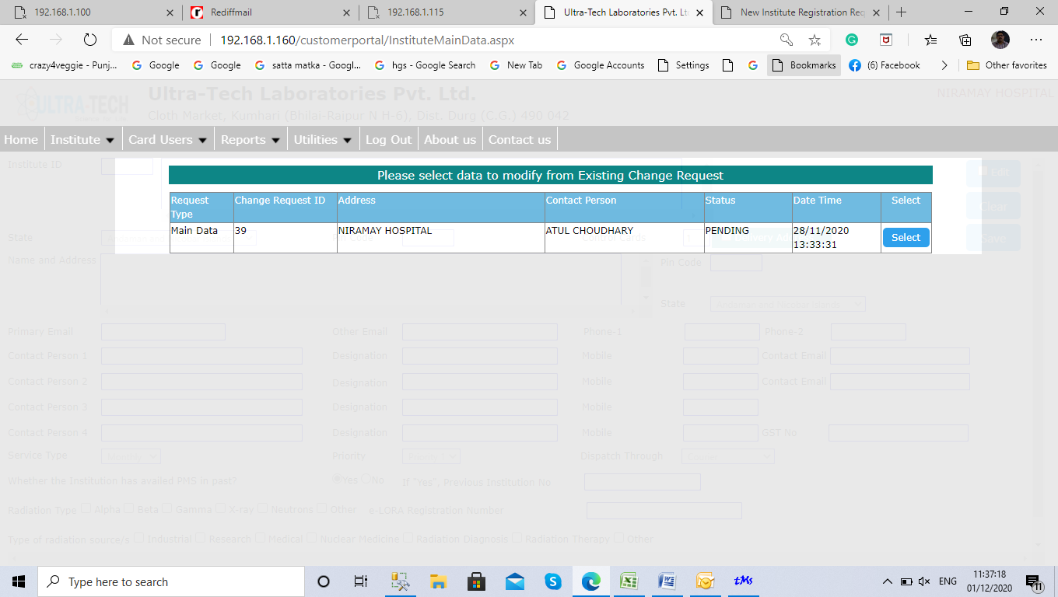
Click here for enter data
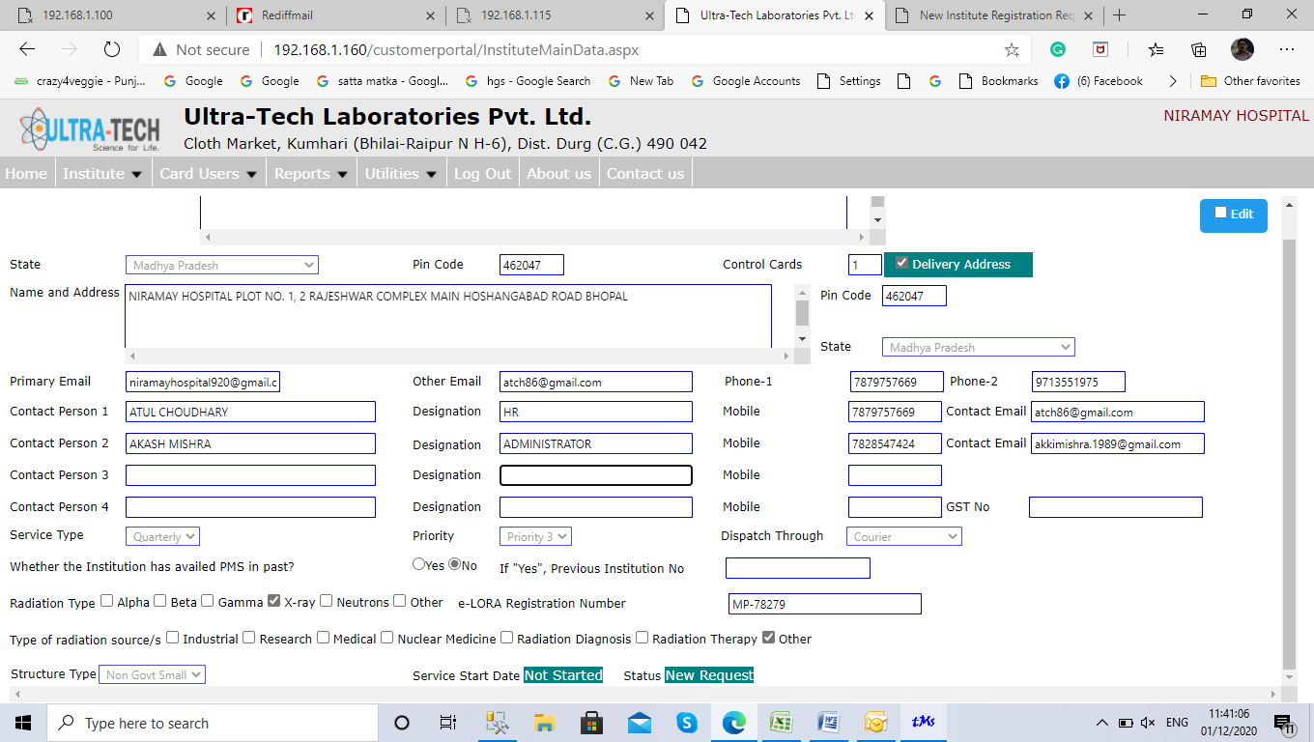
Click Edit checkbox & enter data
Enter machine details & save
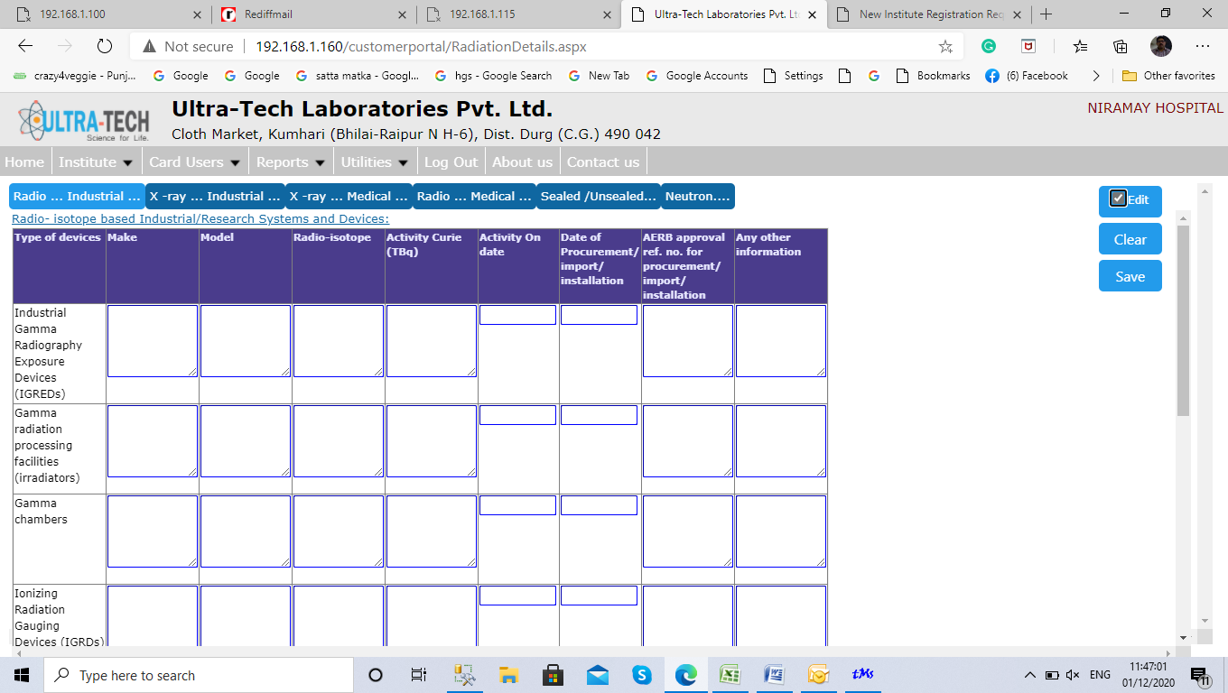

Go to Institute>change request list .select status draft mode & search and click on submit
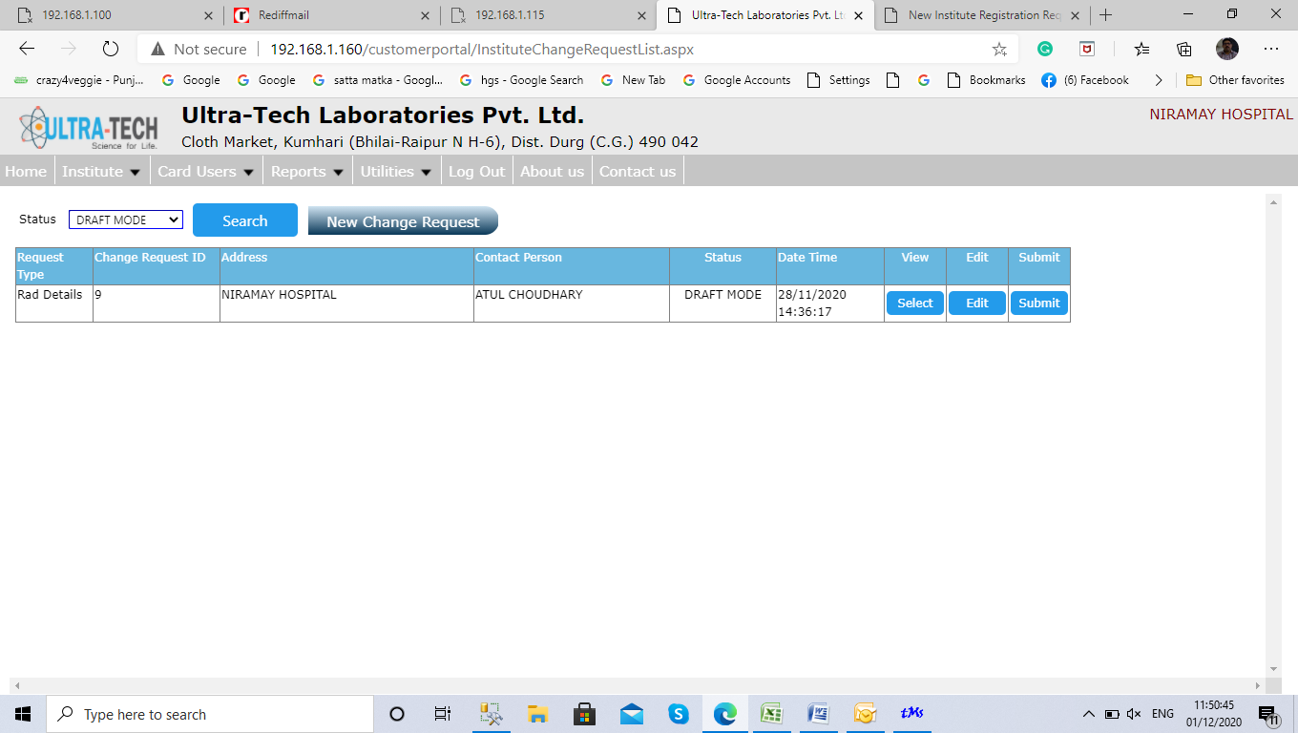
Click here
After approval of admin go to reports >PMS forms final and take print of PMS form Put seal and sign and send hard copy to ultra tech Laboratories Pvt ltd. Contact Mr. Manoj on 6269470003

Add Card Users (Persons)
Go to Card user>New card user and fill the form and save.
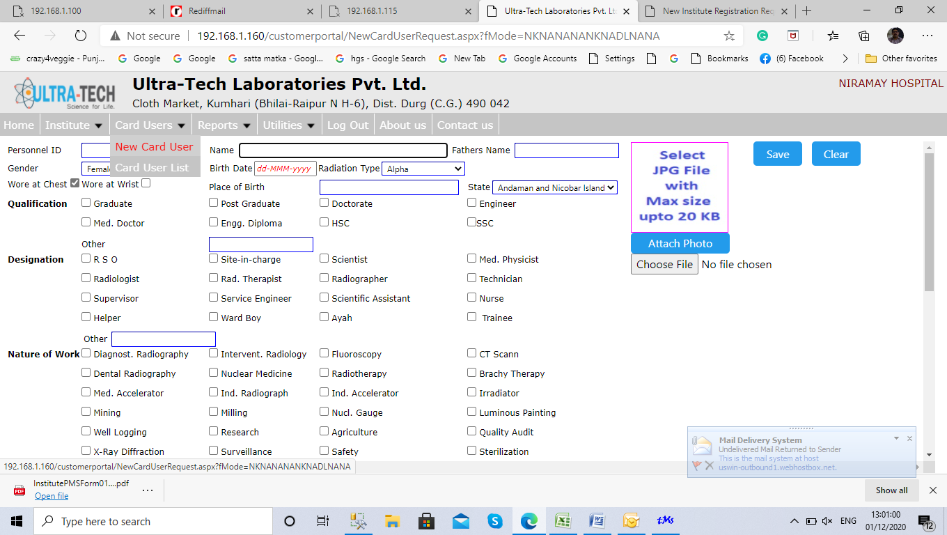
Go to Card user list select status to new request click on search and submit request
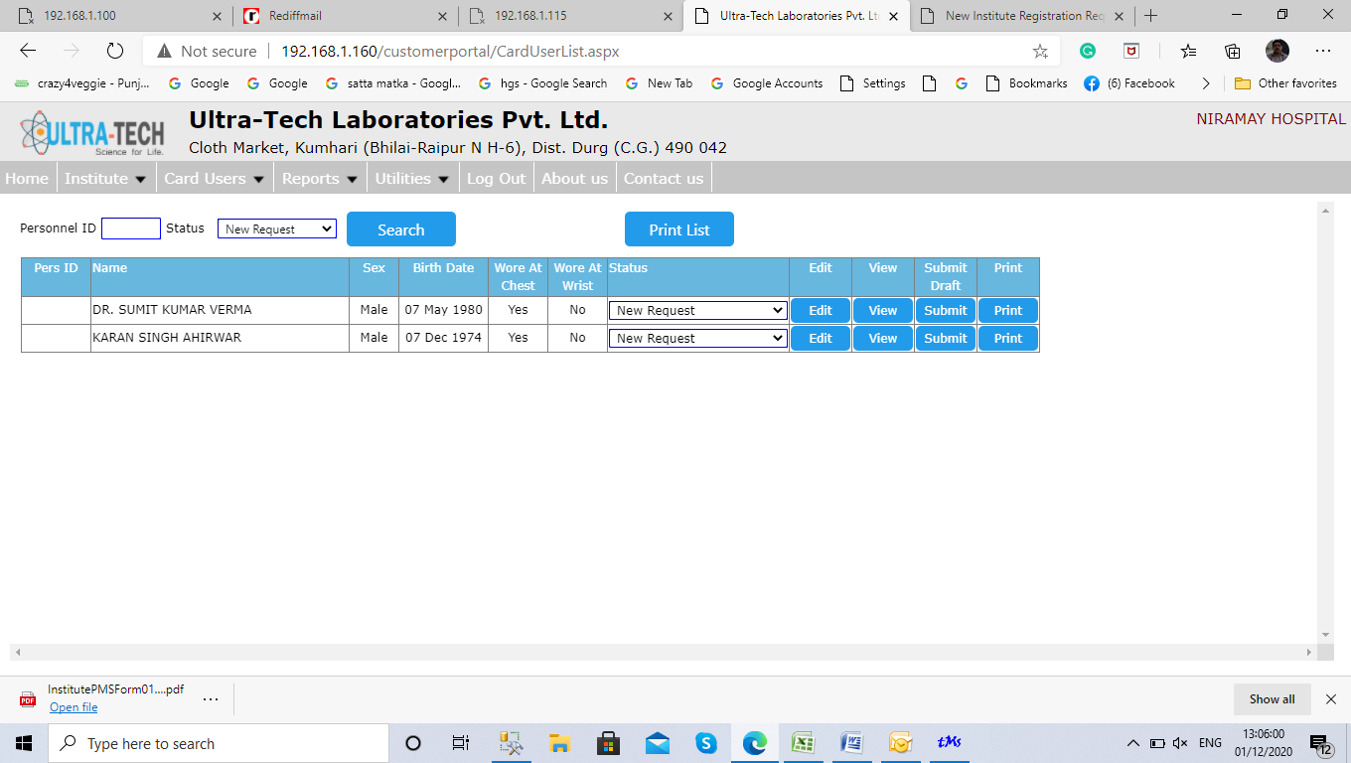
Click to submit

3.Dash Board
Download
1.Dose Report
2.Accounts statement
3.Receipt Invoice

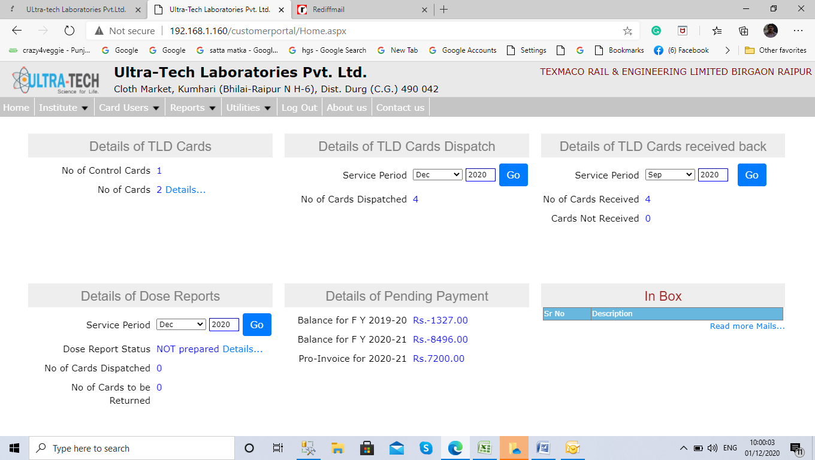
New Institute
Registration
Card user List
Last cards Receipt
Last Cards Dispatch
New Notifications
4.Dose Report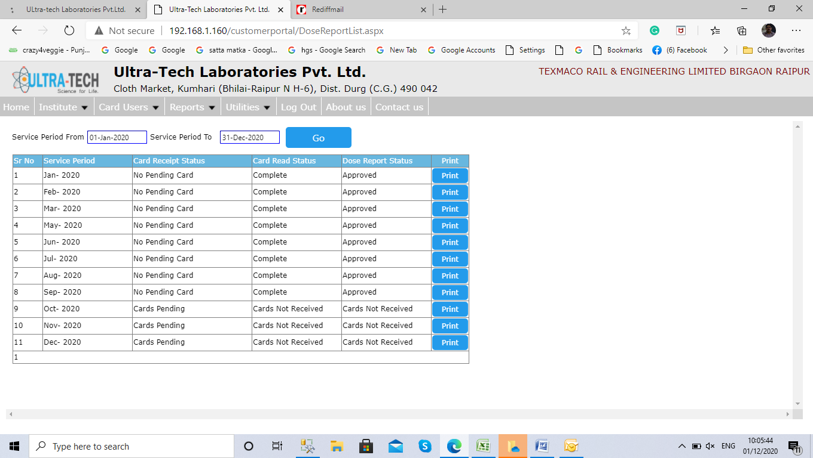
Enter from and to dates
Only approved status can be download.

5. Account statement
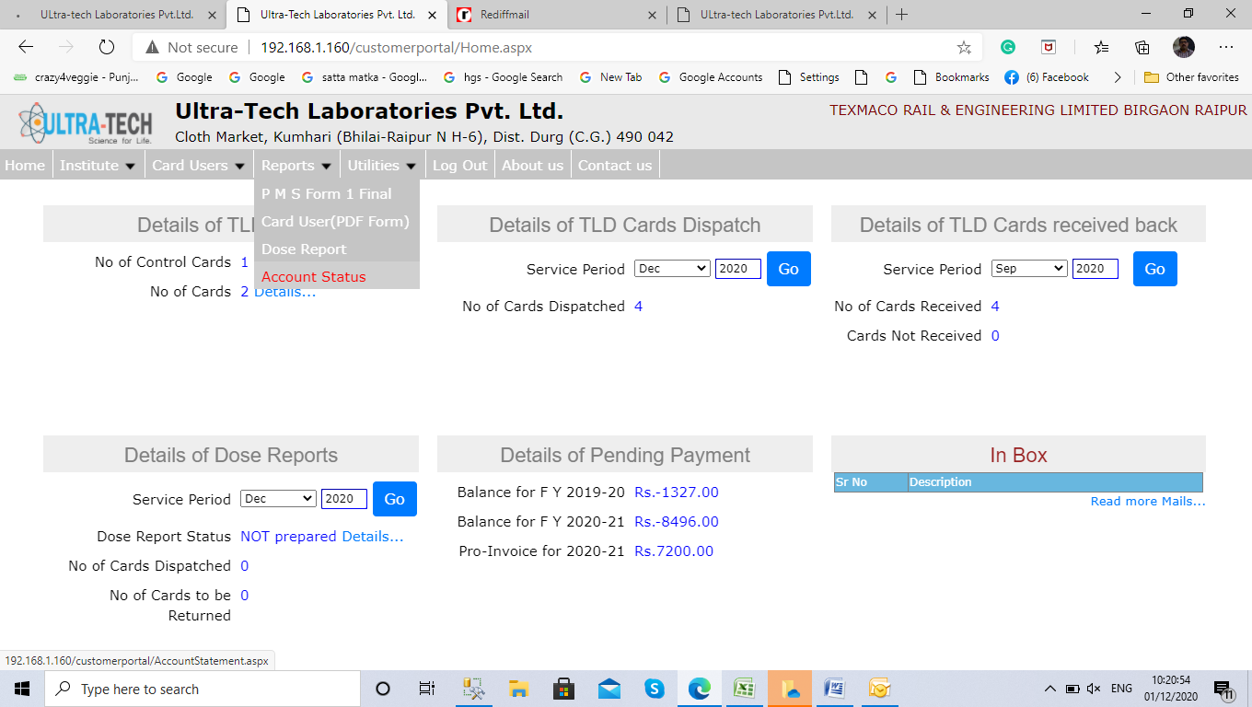
Click here
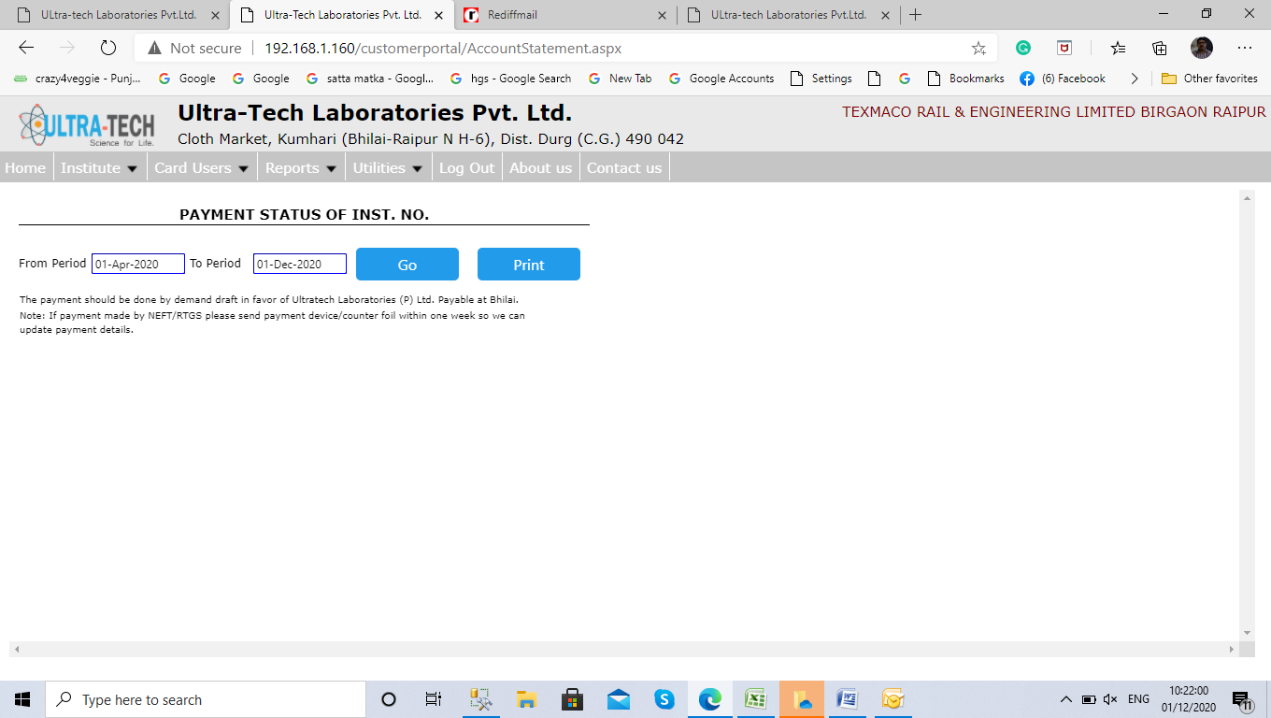
Enter Dates then Click Go Button

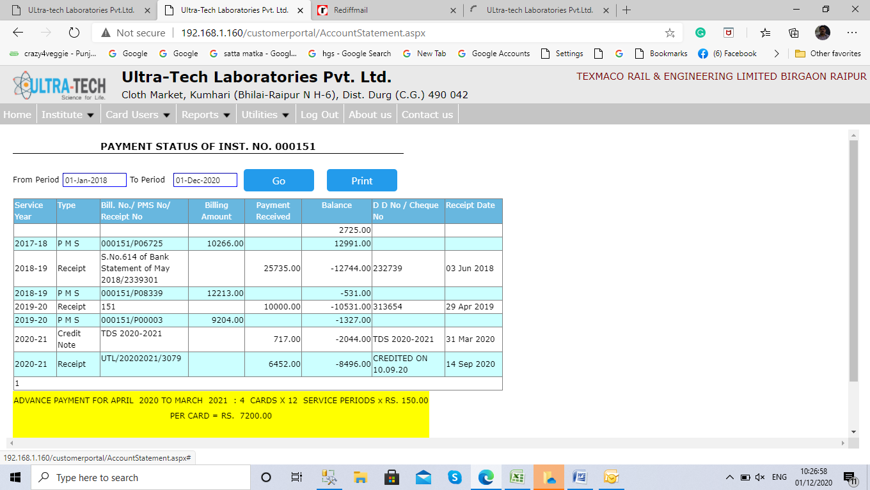
Print account statement
Click here to download invoice, Receipts, credit debit notes etc.

How To Pay Online
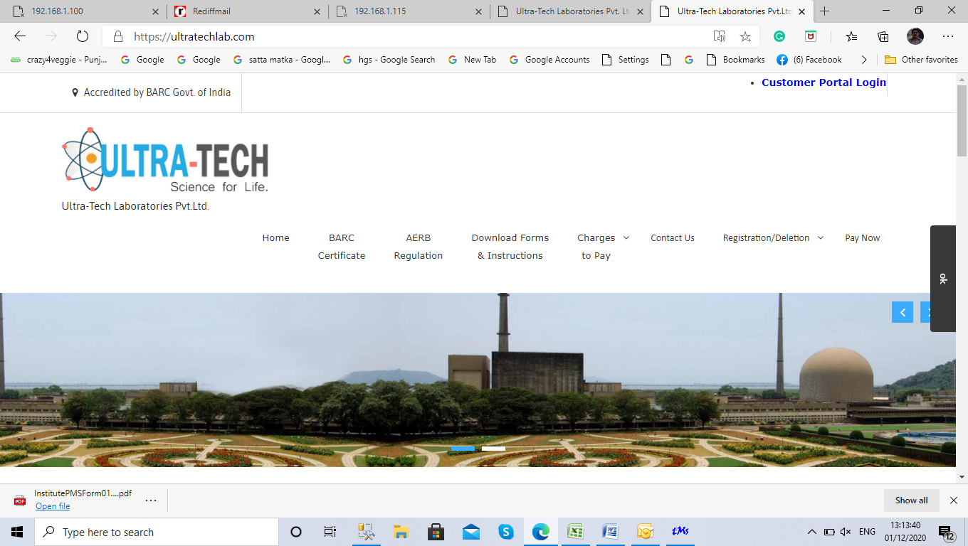
Click here
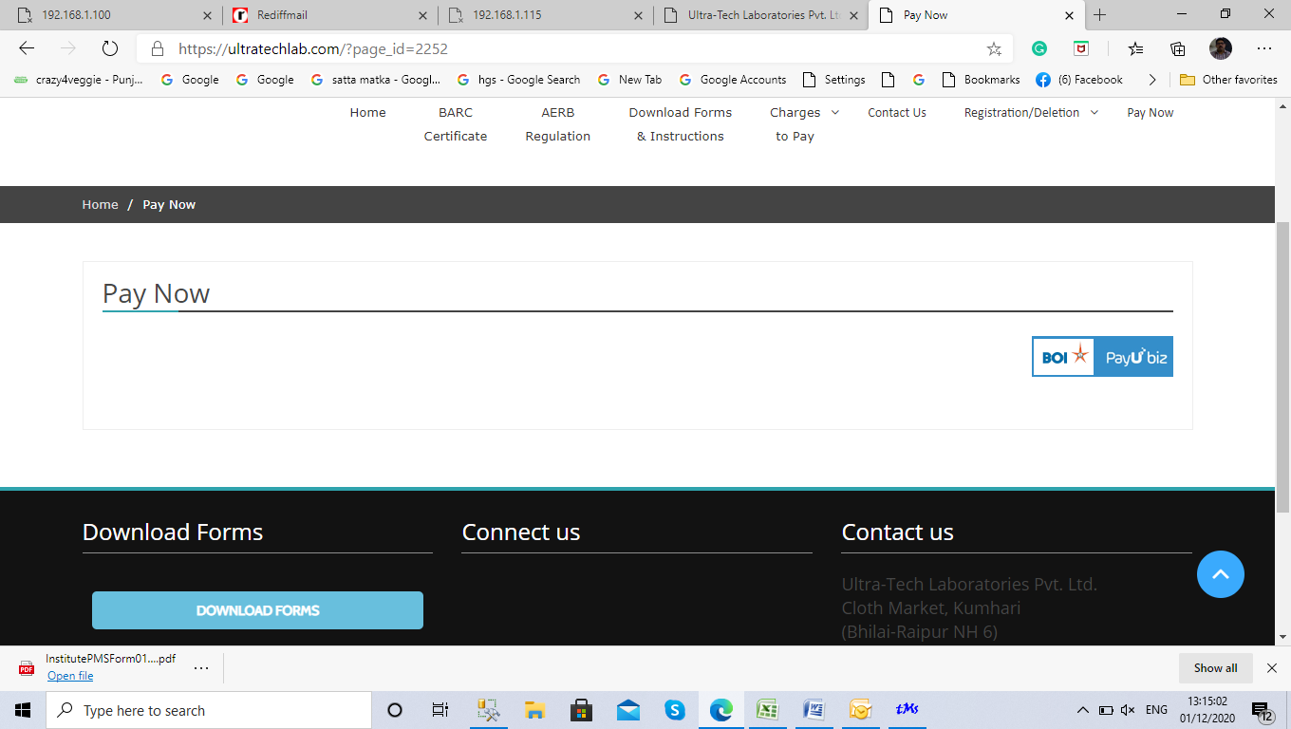
Click here
Enter Details and submit
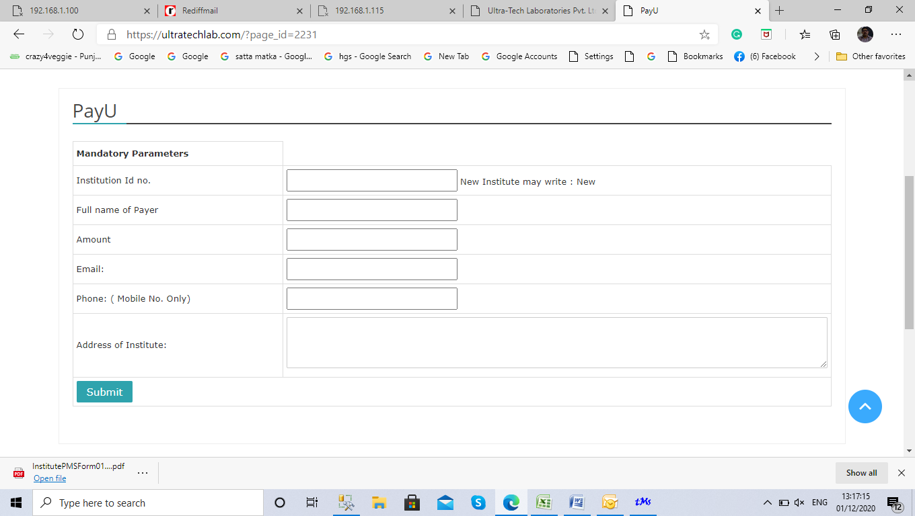

Select Payment mode & pay .
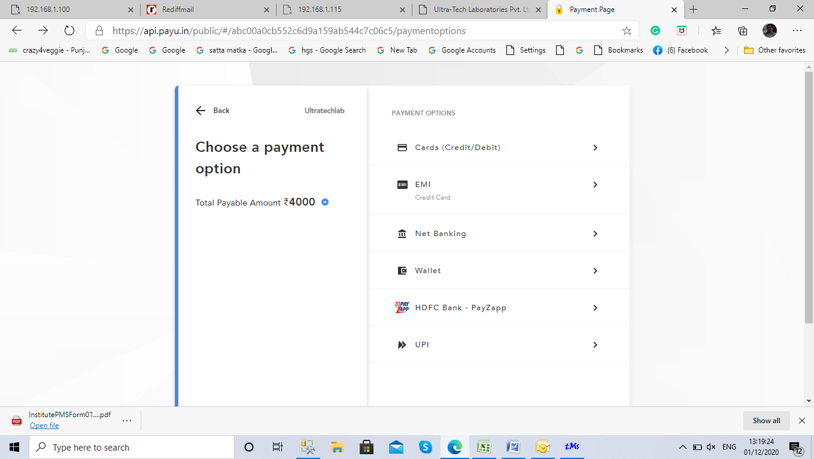

6.Notifications

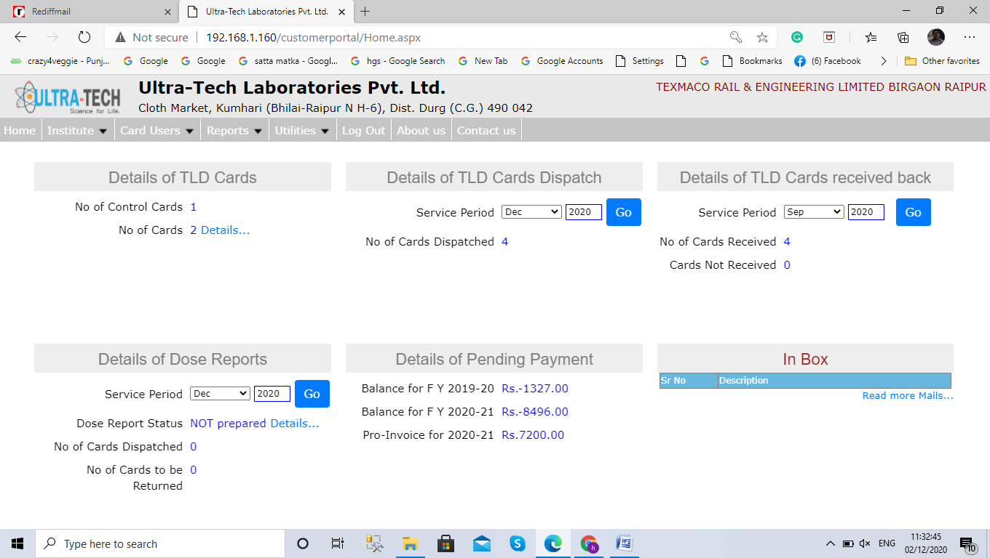
Here You can read new Notifications For any query or complaint Click Here
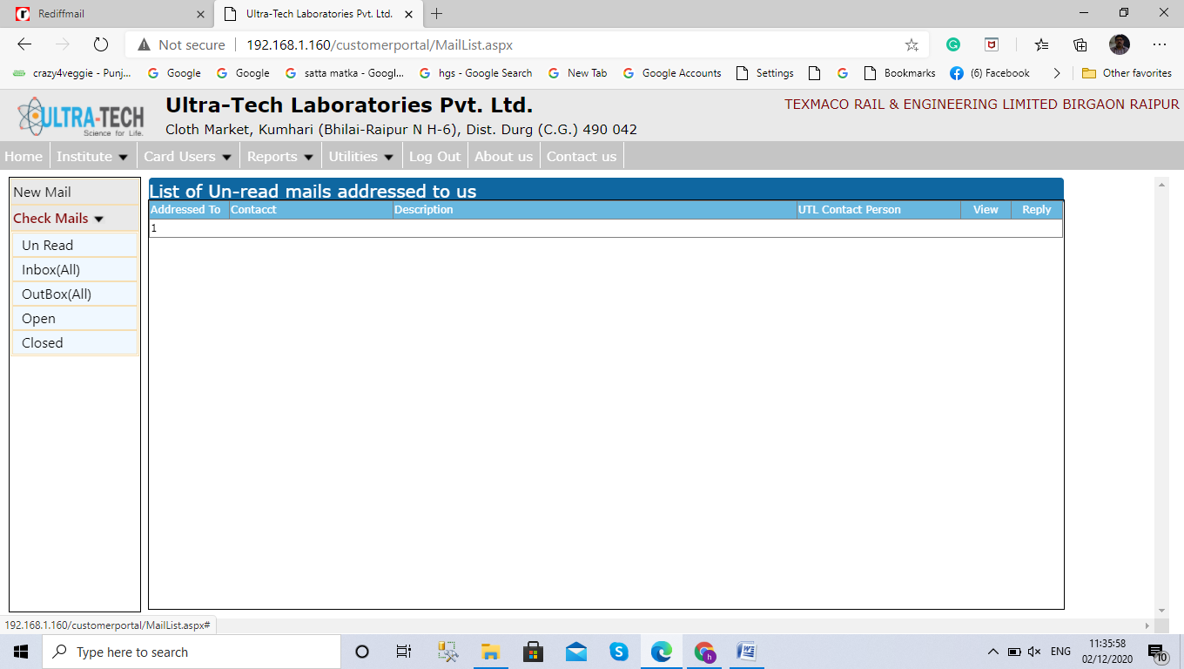
Replay Message
Write mail to
Admin

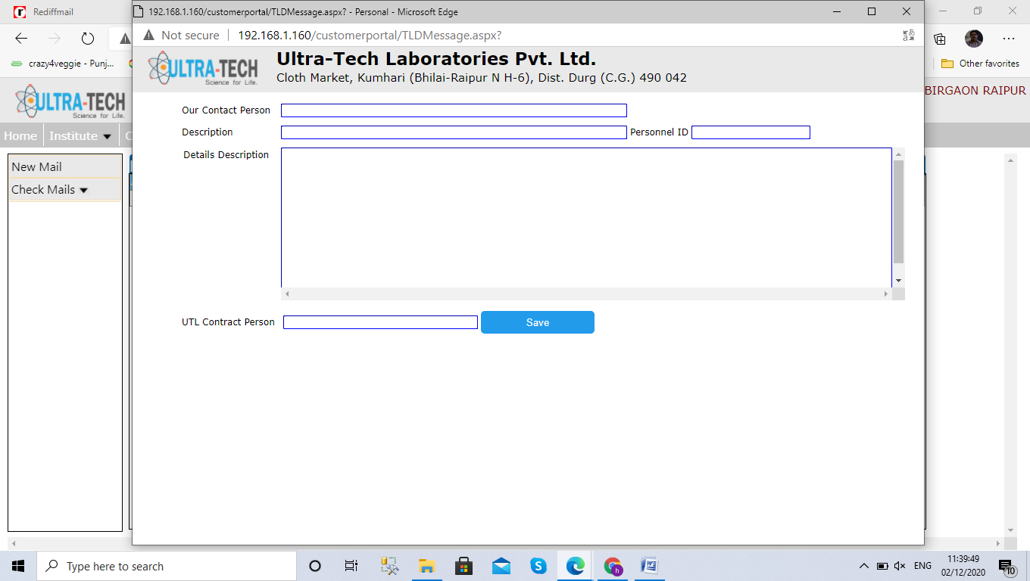

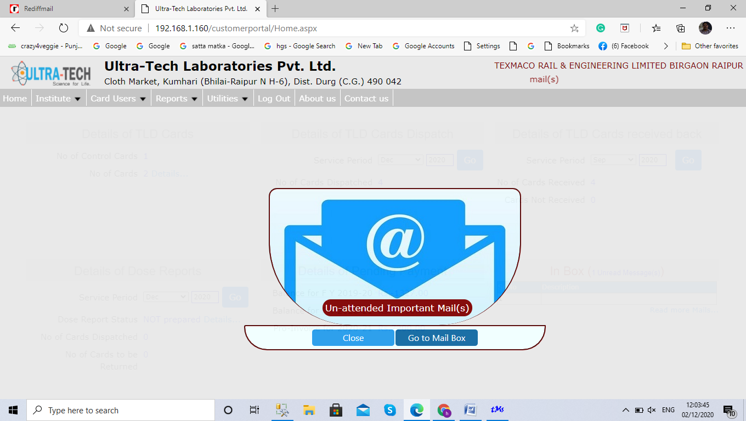
If you see this message on screen .Please go mail box and check mail & reply and contact admin on 6269470003.

